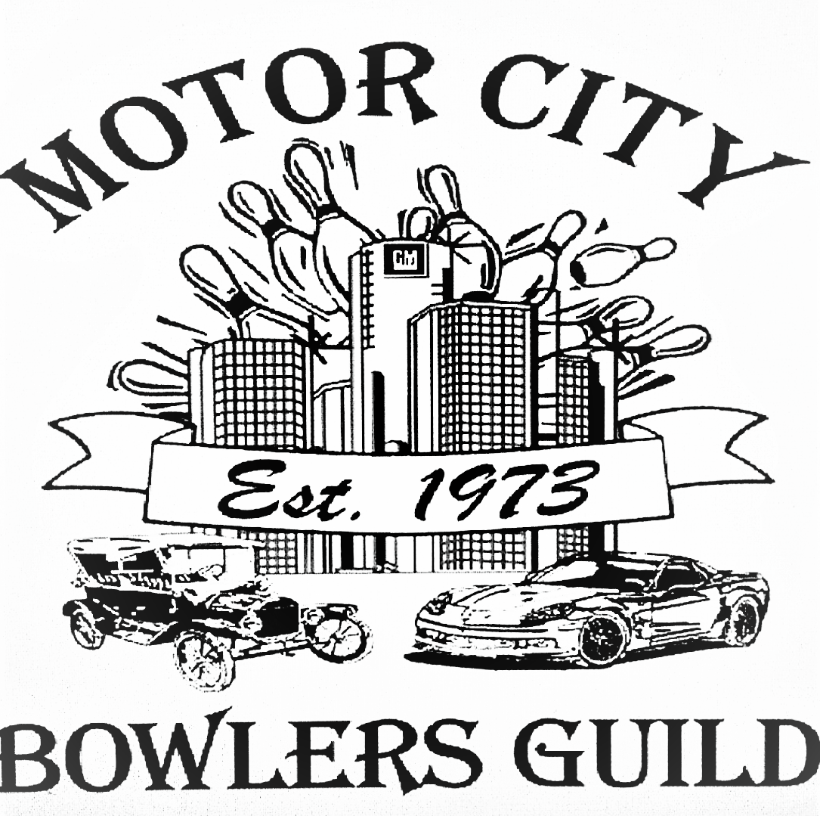

New Year’s Day
9 Pin No Tap Tournament
January 1, 2025

Final Prize List

Handicap Singles
Place | Name | 1st | 2nd | 3rd | Series | Hdcp | Total
1^{st (tie)} | Marcus Daniel Mitchell | 300 | 300 | 300 | 900 | 0 | 900
1^{st (tie)} | Anthony Henderson | 269 | 300 | 296 | 865 | 35 | 900
3rd | Kelvin Irving | 300 | 288 | 265 | 853 | 44 | 897
4th | Desmin Donaldson | 266 | 249 | 260 | 775 | 121 | 896
5th | Tekio Jones II | 277 | 266 | 244 | 787 | 102 | 889
6th | Duane Henderson | 300 | 257 | 300 | 857 | 24 | 881

Optional Doubles
Place | Partners names | Series w/Hdcp | Total
1st | James Ramsey/William Gardner | 876/875 | 1757
2nd | Marcus Daniel Mitchell/Kevin Chubb | 900/840 | 1740
3rd | Marcus Daniel Mitchell/David Page-Bey | 900/825 | 1725
4th | Jaimie Carmichael/Marcus D. Mitchell | 822/900 | 1722
5th | James Ramsey/Otis Smith | 876/842 | 1718

Optional Scratch Singles
Place | Name | 1st | 2nd | 3rd | Series
1st | Marcus Daniel Mitchell | 300 | 300 | 300 | 900
2nd | Kenneth Ross Jr | 252 | 266 | 300 | 818
3rd | Lloyd Stevens | 265 | 300 | 252 | 817

***Remember maximum score with handicap per game is 300. Any questions contact Karen @ 248 417-7875

